Calderwood Primary School Newsletter
2020

Thank you!

I would like to start this newsletter with a huge thank you to all our parents and carers who have supported us to make our car park a safer place for pupils and their families. We have seen a huge improvement in both the volume of traffic and the driving and parking at the front of the school - it has calmed significantly over the past few weeks. We are well aware that there are still issues at the Stonelaw car park and further down Buchanan Drive, but we are looking at promoting a huge change in behaviour and this will not happen overnight. We will continue to do what we can as a school to ensure the safety of pupils and we are open to any ideas and suggestions from our Parent Forum.
We would ask that everybody keeps in mind that the safety of our young people is our absolute priority and the responsibility for this lies with of all of us. We would also ask that we please show respect to each other in our interactions…. We know that tempers can become frayed, but ultimately Calderwood is all about community and we must work together to find a sustainable solution to this problem.

Primary 6 Burns Supper
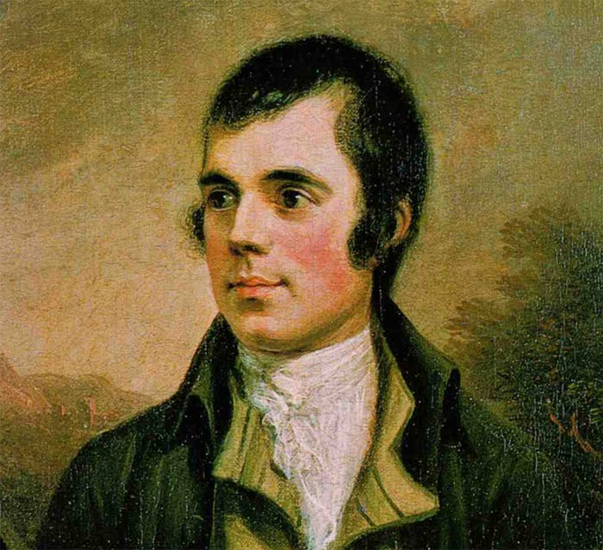

A big ‘well done’ to our Primary 6 pupils and staff for organising and hosting our annual Burns Supper last week.
The event was a huge success with delicious food, super dancing and fabulous entertainment. All your hard work preparing for the event was greatly appreciated by guests.
I am sure Robert Burns himself would have been proud!

Pupil Illness  Another reminder that pupils should be kept at home for 48 hours following a bout of sickness and/or diarrhoea. This is the recommendation from NHS Scotland and following these guidelines helps to reduce the spread of illness.  If your child requires medication during the school day, please request an ‘Administration of Medicines’ form from our office. Medicines should be kept in the school office and picked up by an adult at the end of the day. |  | Please find included with this newsletter a list of dates and times for upcoming events in the school diary.
Head Lice  Head lice are a common occurrence amongst school-age children. Vigilance and proper treatment are key to stopping the spread of head lice. I will send home a leaflet from the NHS which outlines the best way to tackle these nuisance creatures. | Nut-Free School  Please remember that we are a nut-free school as we have a number of pupils with severe allergies. Please do not send nut-based products into school with child, including snacks such as Nutella. Your help with this is greatly appreciated.
Autumn Club  A number of pupils visited the community group The Autumn Club in Burnside Church last week to entertain them with Burns poetry, songs and music. As always, they represented the school proudly and the audience really enjoyed the performances. Well done all who attended! | P7 Sports Leaders  Our Primary 7 pupils have been working with our Active Schools leader Josh, who is training them to become Sports Leaders. The Primary 7s will then be able to run sessions with younger pupils. This is a great opportunity for our pupils to take on leadership roles and they are thoroughly enjoying the opportunity.
Primary 7 Residential Trip: Lockerbie Manor

Primary 7 are busy preparing for one of the highlights of their year – their residential trip to Lockerbie Manor. They will be accompanied this year by Mrs Ring, Mrs Bloomer, Miss Turpin and Mr David Sampson.

Parents’ Evenings  Our second Parents’ evenings of the session will take place on 26th and 27th February 2020. We have already issued appointment times and we thank you very much for your patience with this process. If your allocated time does not suit, there is still time to phone the office to rearrange. We look forward to seeing everyone on these dates. | School Clubs  We have a huge number of clubs running presently, both during lunchtimes and after school. These include football, netball, arts and crafts, writing, dancing and running. Over the course of this session we hope to engage all pupils in at least one club and we aim to offer a wide range of activities. As always, we are open to ideas and suggestions for future activities.
Thinking Day

On Friday 21st February we will be celebrating Thinking Day by inviting all pupils to come to school dressed in club uniforms (Brownies, Guides, BB, judo, etc.) if they wish. The idea is to celebrate the wide range of interests our pupils have beyond school.

